Screenshot of R version
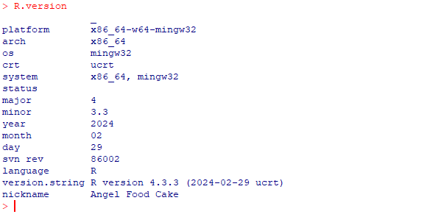
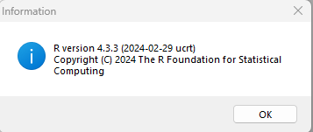

Screenshot of R Studio IDE version

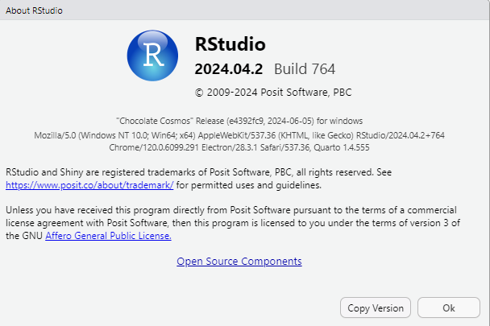

Analytics Programming Week-1 Solutions
2024-08-28
#Solution 1: creating numeric, character, logical and date data type
numeric_variable <- 11
char_variable <- 'a'
logical_variable <- TRUE
as.Date('2024-08-11')->date_variable
#validating the data type
print(paste("First data is", class(numeric_variable), "type."))
## [1] "First data is numeric type."
print(paste("Second data is", class(char_variable), "type."))
## [1] "Second data is character type."
print(paste("Third data is", class(logical_variable), "type."))
## [1] "Third data is logical type."
print(paste("Fourth data is", class(date_variable), "type."))
## [1] "Fourth data is Date type."
#Solution 2: vector of the names of the days of the week.
monthsOfYEAR <- c("Sunday","Monday","Tuesday","Wednesday","Thursday","Friday","Saturday")
print(monthsOfYEAR)
## [1] "Sunday" "Monday" "Tuesday" "Wednesday" "Thursday" "Friday"
## [7] "Saturday"
#Solution 3: vector of numbers that ranges from 200 to 220
dataVec1 <- 200:220
print(paste("Vector of number from 200 to 220 is: ",dataVec1))
## [1] "Vector of number from 200 to 220 is: 200"
## [2] "Vector of number from 200 to 220 is: 201"
## [3] "Vector of number from 200 to 220 is: 202"
## [4] "Vector of number from 200 to 220 is: 203"
## [5] "Vector of number from 200 to 220 is: 204"
## [6] "Vector of number from 200 to 220 is: 205"
## [7] "Vector of number from 200 to 220 is: 206"
## [8] "Vector of number from 200 to 220 is: 207"
## [9] "Vector of number from 200 to 220 is: 208"
## [10] "Vector of number from 200 to 220 is: 209"
## [11] "Vector of number from 200 to 220 is: 210"
## [12] "Vector of number from 200 to 220 is: 211"
## [13] "Vector of number from 200 to 220 is: 212"
## [14] "Vector of number from 200 to 220 is: 213"
## [15] "Vector of number from 200 to 220 is: 214"
## [16] "Vector of number from 200 to 220 is: 215"
## [17] "Vector of number from 200 to 220 is: 216"
## [18] "Vector of number from 200 to 220 is: 217"
## [19] "Vector of number from 200 to 220 is: 218"
## [20] "Vector of number from 200 to 220 is: 219"
## [21] "Vector of number from 200 to 220 is: 220"
# Solution 4: Vecotr of numbers that ranges from 40 to 60
dataVec2 <- seq(from = 40, to = 60, by = 1)
print(dataVec2)
## [1] 40 41 42 43 44 45 46 47 48 49 50 51 52 53 54 55 56 57 58 59 60
# Solution 5: adding two vector
dataCombVec1 <- c(dataVec1, dataVec2)
print( dataCombVec1)
## [1] 200 201 202 203 204 205 206 207 208 209 210 211 212 213 214 215 216 217 218
## [20] 219 220 40 41 42 43 44 45 46 47 48 49 50 51 52 53 54 55 56
## [39] 57 58 59 60
# Solution 6: multiplying two vector
datacombVec2 <- dataVec1 * dataVec2
print(datacombVec2)
## [1] 8000 8241 8484 8729 8976 9225 9476 9729 9984 10241 10500 10761
## [13] 11024 11289 11556 11825 12096 12369 12644 12921 13200
#Solution 7
# NULL -> it represents the absence of value or missing value
#NA -> means undefined data within the data. You can remove NA using `NA.rm` to use sum command
# Solution 8: code that will install dplyr package in RStudio
install. packages('dplyr')
library(dplr)
packageVersion('dplyr')
## [1] '1.1.4'
summary(cars)
## speed dist
## Min. : 4.0 Min. : 2.00
## 1st Qu.:12.0 1st Qu.: 26.00
## Median :15.0 Median : 36.00
## Mean :15.4 Mean : 42.98
## 3rd Qu.:19.0 3rd Qu.: 56.00
## Max. :25.0 Max. :120.00

Including Plots
You can also embed plots, for example:
